**E-governance Services Installation**

By

Pragisha Prajapati

*In partial fulfillment of the requirements for Bachelors of Science in Computer Science and Information Technology*

National College of Computer Studies

Paknajol, Nepal

May,2024

**Table of Contents**

Chapter 1: Introduction to E-Banking 1

Chapter 2: eSewa 2

Chapter 3: connectIPS 5

Chapter 4: Banking Service 9

Chapter 5: Nagarik App 13

Chapter 6: Conclusion 16

# Introduction to E-Banking

E-banking in Nepal involves the use of electronic means by financial institutions to offer banking services. This includes online banking, mobile banking, and various digital payment solutions. The growth of e-banking in Nepal has been driven by increased internet penetration, the widespread use of smartphones, and the government's push towards a digital economy.

Key features of e-banking in Nepal include:

1. **Online Banking**: Allows customers to perform a variety of banking transactions via the internet, such as checking account balances, transferring funds, and paying bills.
2. **Mobile Banking**: Provides banking services through mobile applications, enabling customers to access their accounts, transfer money, and pay for goods and services using their mobile phones.
3. **Digital Payment Systems**: Includes services like e-wallets (e.g., eSewa, Khalti), QR code payments, and mobile money services that facilitate cashless transactions.

Through this technology, information related to bank account, remittance of required amount, keeping and withdrawing required amount and other service facilities can also be obtained. Such tools have reduced the amount of money transactions and freed from the hassle of having to carry money to make payments.

**Banking services:**

1. eSewa
2. connectIPS
3. Sanima Banking Service
4. Nagarik app

# eSewa

eSewa, Nepal's first digital wallet and online payment gateway launched in 2009 by F1Soft International, revolutionizes financial transactions by enabling users to store money digitally and make payments effortlessly. It offers services such as utility bill payments, mobile recharges, bank transfers, merchant payments, and event ticketing. Being a digital platform, an individual who owns the right of being citizen of the state can register in eSewa without any charges. An individual must own the nationality certificate as citizenship/license/passport/voter’s ID card to register in eSewa. It is a business entity regulated by the Nepal Rastra Bank’s rules and regulations hence, it is the safe and easy mode of payment.

**Installation Process**

**Step 1:** **Download the App**:

* For **Android**: Open the Google Play Store, search for "eSewa" and tap "Install."
* For **iOS**: Open the Apple App Store, search for "eSewa" and tap "Get" to download and install the app.
* Also, can be accessed in web.

Play Store: <https://play.google.com/store/apps/details?id=com.f1soft.esewa&pli=1>

App store: <https://apps.apple.com/us/app/esewa/id614370939>

Web: <https://esewa.com.np/#/home>

**Step 2: Open the App.**

**Step 3: Sign Up**:

* If you do not have an eSewa account, tap on "Sign Up."
* Enter your mobile number and tap "Next."

**Step 4:** **Log In**:

* If you already have an eSewa account, tap on "Log In."
* Enter your registered mobile number and password.

**Step 5:** **Set Up Security**:

* You will get a verification code through SMS and create MPIN.
* Set up a PIN or biometric authentication (fingerprint or face recognition) if your device supports it. This ensures secure access to your eSewa wallet.

**Step 6:** Use eSewa for different online transactions.

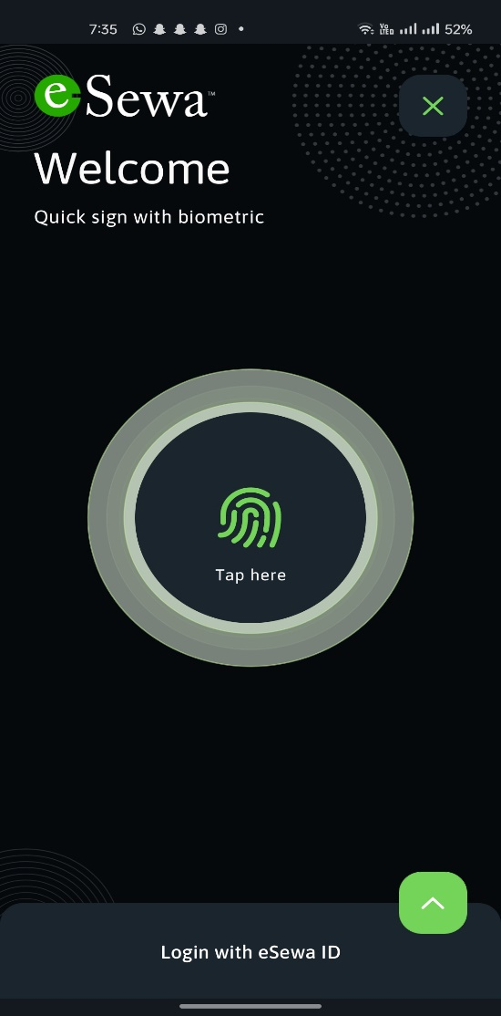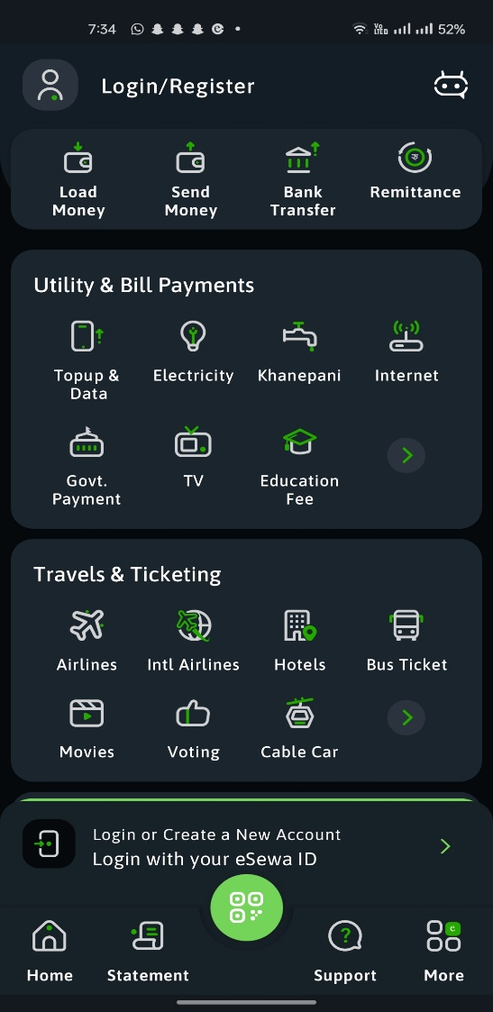**Screenshots:**

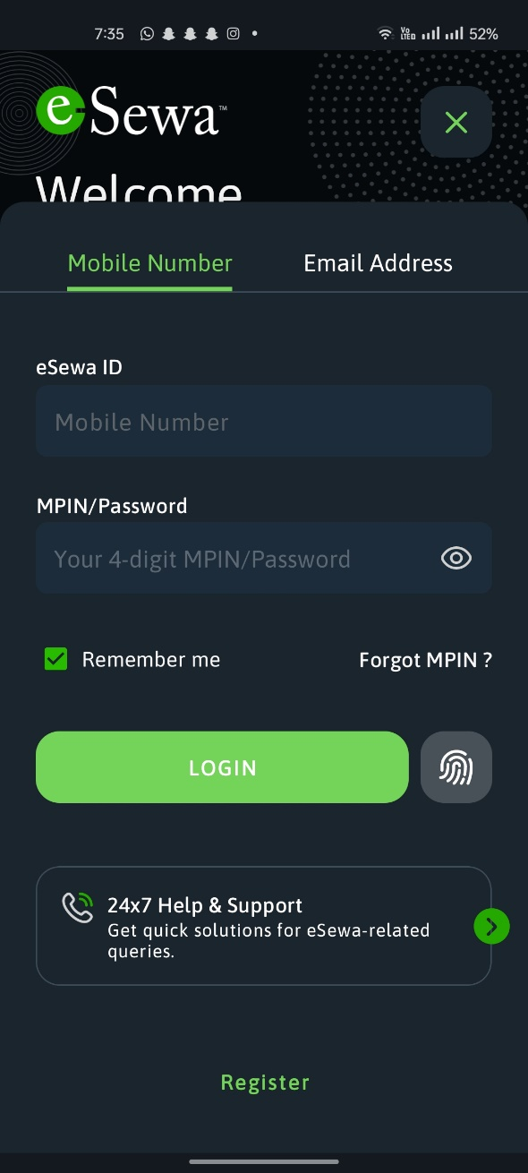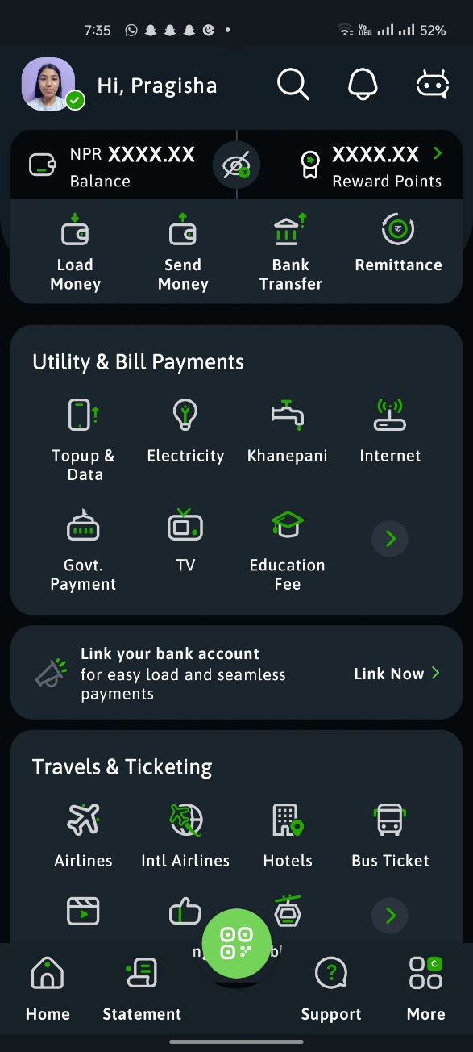

**Features:**

* Store money digitally for easy and secure transactions.
* Pay utility bills, internet, and telephone bills hassle-free.
* Recharge mobile phone credits instantly for all major telecom operators.
* Transfer funds between bank accounts and eSewa wallets seamlessly.
* Make purchases at various online and offline merchants.
* Purchase tickets for events, movies, and transportation.
* Ensure the safety of transactions with encryption and two-factor authentication.
* Enjoy an intuitive app design for easy navigation and use.

# connectIPS

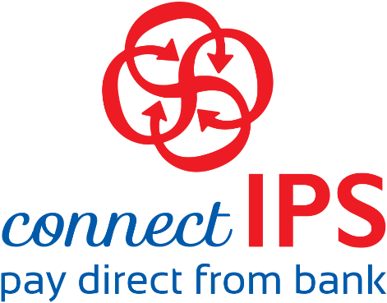connectIPS is a comprehensive digital payment system in Nepal that enables seamless inter-bank transactions and payments. Managed by Nepal Clearing House Limited (NCHL), connectIPS allows users to link multiple bank accounts and perform real-time fund transfers, utility bill payments, government payments, and more through a single platform. It supports secure and convenient transactions, promoting a cashless economy and financial inclusion. Users can access connectIPS via its web portal or mobile app, making it a versatile and essential tool for digital financial management in Nepal.

**Installation Process:**

**Step 1:** **Download the App**:

* For **Android**: Open the Google Play Store, search for "connectIPS" and tap "Install."
* For **iOS**: Open the Apple App Store, search for "connectIPS" and tap "Get" to download.
* Also can be accessed in web.

Web:  https://login.connectips.com/#/register

Play store: <https://goo.gl/hCvs3j>

App store: <https://itunes.apple.com/us/app/connectips/id1449940087?ls=1&mt=8>

**Step 2: Open the App**.

**Step 3: Register an Account**:

* If you do not have a connectIPS account, tap on "Sign Up."
* Enter the required information, such as your personal details and a valid mobile number.
* Create a username and password for your connectIPS account.

**Step 3: Verify Your Account**:

* After registration, you will receive a verification code on your mobile number.
* Enter the verification code in the app to verify your account.

**Sep 4: Link Your Bank Account**:

* Log in to your connectIPS account.
* Navigate to the "Link Bank Account" section.
* Select your bank from the list of participating banks.
* Provide your bank account details, such as account number and other required information.
* Submit the details for verification.

**Step 5: Bank Verification**:

* Your bank will verify the account linking request. This process may take some time.
* Once verified, you will receive a confirmation notification.

**Step 6: Set Up Security**:

* For enhanced security, set up a transaction PIN or enable biometric authentication (fingerprint or face recognition) if your device supports it.

**Step 7: Start Using connectIPS**:

* After successful verification and setup, you can start using connectIPS for various financial transactions such as fund transfers, bill payments, and more.

**Screenshots:**

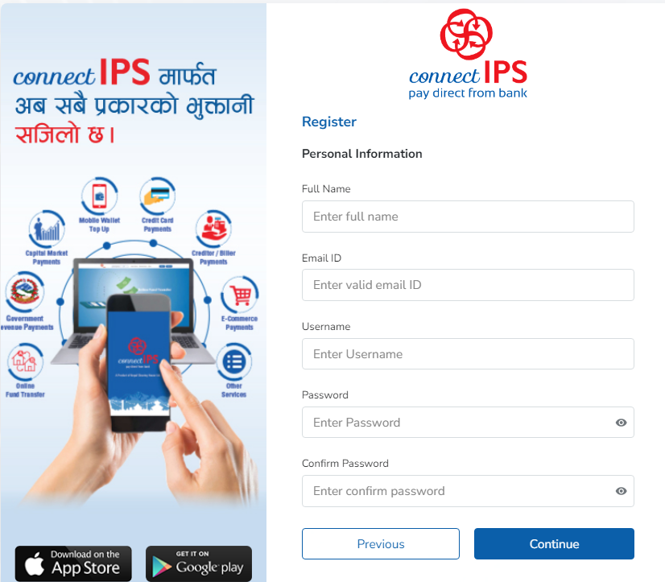

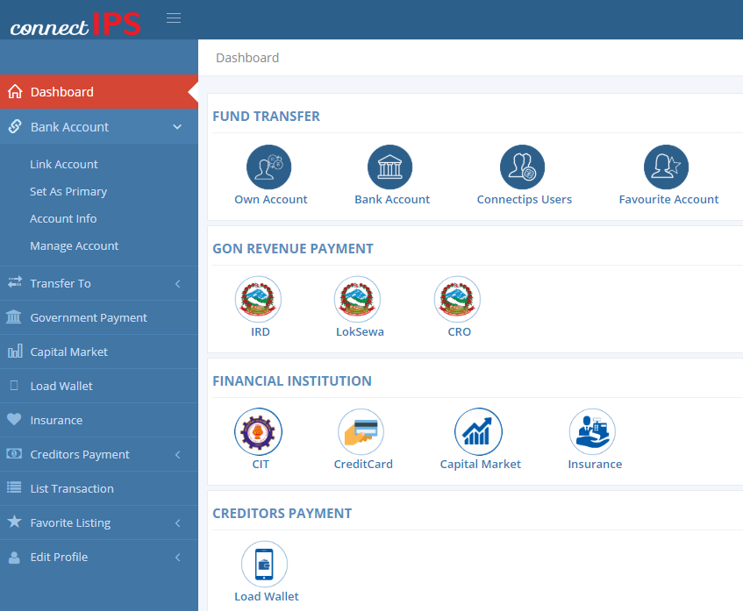

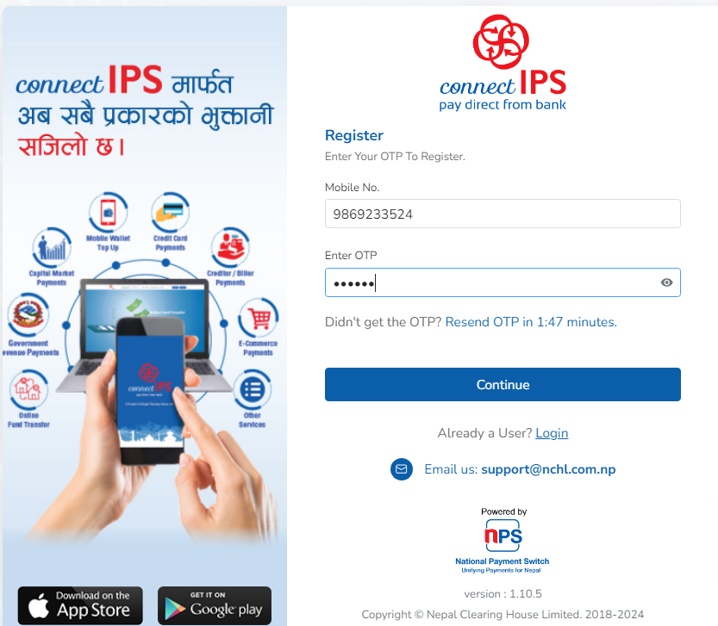

**Features:**

* Transfer funds between bank accounts in real-time.
* Pay utility bills, credit card bills, and other payments conveniently.
* Recharge mobile phone credits directly through the app.
* Send and receive domestic and international remittances seamlessly.
* Access detailed records of past transactions for reference.
* View account balances and monitor transaction activity.
* Receive real-time alerts for transactions and account activities.
* Ensure secure transactions with advanced authentication methods for user protection.
* Manage accounts from multiple banks within the same app for added convenience.
* Enjoy an intuitive and easy-to-use interface for smooth navigation and operation.

# Banking Service

Sanima Bank Limited stands out in Nepal's banking sector with its robust e-banking services tailored to meet the evolving needs of its diverse clientele. With internet banking, customers gain seamless access to their accounts for transactions, bill payments, and statement viewing from the comfort of their homes or offices. Moreover, SMS banking offers quick updates on transactions and account balances, providing added flexibility. Sanima Bank's card services further enhance accessibility, allowing customers to manage their cards and conduct secure transactions effortlessly. In essence, Sanima Bank's e-banking suite epitomizes modern banking convenience, blending technological innovation with customer-centric solutions for an enhanced banking experience.

**Installation Process:**

**Step 1:** **Download the App**:

* For **Android**: Open the Google Play Store on your Android device. <https://play.google.com/store/apps/details?id=com.f1soft.sanimamobilebanking&hl=en>
* For **iOS**: Open the Apple App Store on your iOS device. <https://apps.apple.com/in/app/sanima-sajilo-e-banking/id929997212>
* Also, can be accessed in web. <https://sajiloebanking.sanimabank.com/>

**Step 2: Open the App**.

**Step 3: Register/Login**:

* If you are a new user, tap on the "Register" or "Sign Up" option.
* Provide your account details, personal information, and create a username and password.
* If you are an existing user, enter your username and password to log in.

**Step 4: Set Up Security**:

* Follow the prompts to set up additional security measures such as a PIN or biometric authentication (if supported by your device).

**Step 5: Explore Features**:

* Once logged in, you can explore the various features and services offered by the Sanima Bank mobile banking app.
* These may include checking account balances, transferring funds, paying bills, locating ATMs/branches, and more.

**Step 6: Start Using the App**:

* Once you've set up your account and explored the features, you can start using the Sanima Bank app for your banking needs.

**Screenshots:**

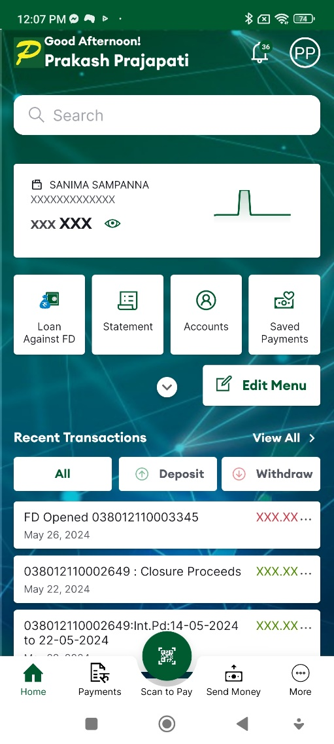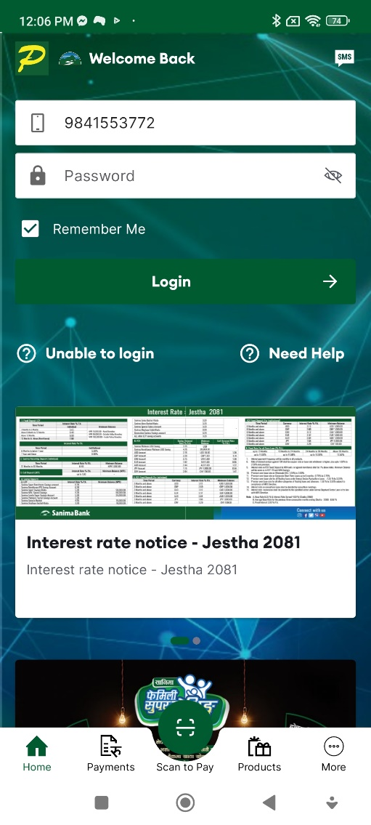

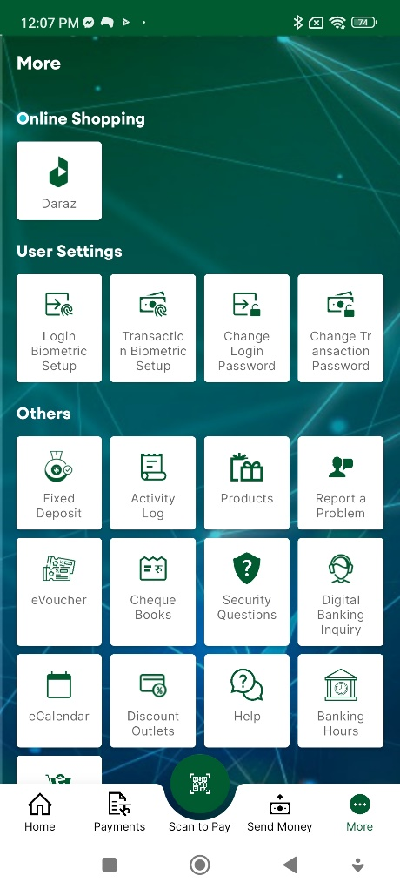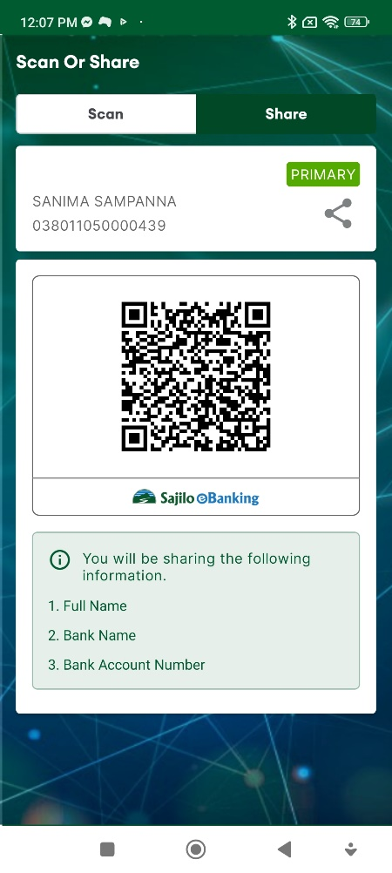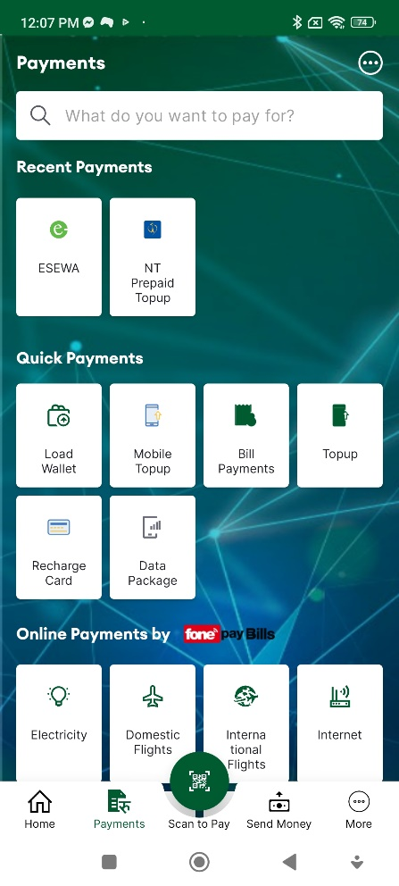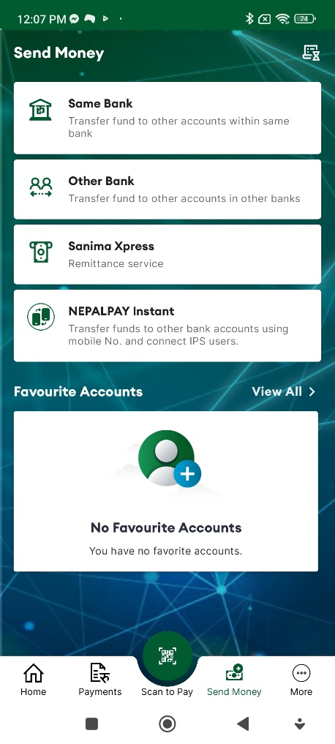

**Features:**

* Check account balances and view transaction history.
* Transfer funds between Sanima Bank accounts and to other banks.
* Pay utility bills, credit card bills, and other payments conveniently.
* Recharge mobile phone credits directly through the app.
* Find nearby ATMs and branches for easy access to banking services.
* Manage debit and credit cards, including blocking and unblocking.
* Receive real-time alerts for transactions and account activities.
* Set up additional security measures like PINs or biometric authentication.

# Nagarik App

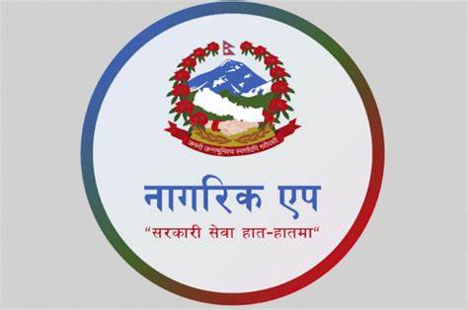Nagarik App is a multifunctional mobile application launched by the Government of Nepal to provide citizens with convenient access to various government services and information. It serves as a centralized platform where users can avail services such as passport applications, driving license renewals, birth and death registrations, and access to important government notices and announcements. The app aims to streamline administrative processes, reduce paperwork, and enhance transparency and efficiency in delivering public services. With its user-friendly interface and wide range of features, Nagarik App empowers citizens to engage with government services digitally, contributing to the country's digitalization efforts and promoting greater citizen-government interaction.

**Installation Process:**

**Step 1: Download the App**:

* For **Android**: Open the Google Play Store on your Android device. <https://play.google.com/store/apps/details?id=com.yajtech.nagarikapp&hl=en&gl=US>
* For **iOS**: Open the Apple App Store on your iOS device. <https://apps.apple.com/us/app/nagarik-app/id1493013430>

**Step 2: Open the App**.

**Step 4: Set Up Your Account**:

* Upon opening the app, you may be prompted to create an account.
* Provide the required information, such as your name, mobile number, and email address.
* Follow the on-screen instructions to complete the registration process.

**Step 4: Start Using the App**:

* You can start using it to access government services, information, and announcements conveniently from your mobile device.

**Screenshots:**

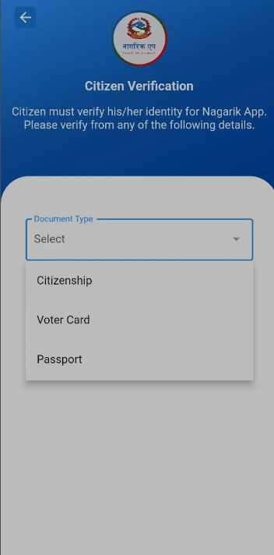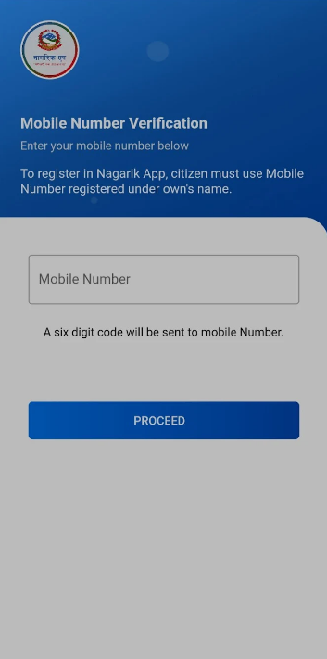**Account Setup:**

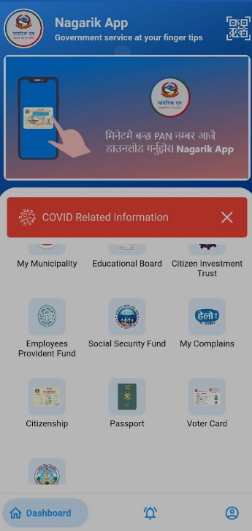**Home screen:**

**Features:**

* Apply for essential documents like passports, licenses, and certificates.
* Access government notices, circulars, and announcements.
* Track the status of service applications in real-time.
* Find information on government policies and initiatives.
* Provide feedback and report grievances on services.
* Make secure online payments for government services.
* Schedule appointments for various government services.
* Support for multiple languages for inclusivity and accessibility.

# Conclusion

In the digital age, mobile applications like eSewa, connectIPS, Sanima Bank, and Nagarik App have revolutionized how we manage our finances and interact with government services. The installation process for these apps is designed to be user-friendly and accessible, ensuring that even those with minimal technical knowledge can benefit from their features.

Each of these applications brings a unique set of features tailored to enhance user convenience. eSewa serves as a versatile digital wallet, allowing for bill payments, mobile top-ups, and merchant transactions, while connectIPS facilitates real-time fund transfers, bill payments, and remittances. Sanima Bank's app offers comprehensive banking services, including fund transfers, bill payments, and account management. The Nagarik App stands out by providing access to government services, such as applying for documents and receiving official notices. These features collectively cater to a wide range of needs, from everyday financial transactions to essential government interactions, promoting a more efficient and streamlined user experience.

The adoption of these apps signifies a significant shift towards digitalization in Nepal, enhancing the ease of conducting financial transactions and accessing public services. By enabling secure, real-time operations and reducing the need for physical visits to banks or government offices, these apps not only save time but also enhance security and transparency. As more users embrace these digital platforms, the overall efficiency of financial and administrative processes is expected to improve, driving the country towards a more connected and technologically advanced future.